[1]

**Surveillance and Intrusion Detection System**

Ganesh Dongre , Vishal Shinde1, Mangesh Shinde2, Devashish Shriwas3, Siddhant Shirode4

Department of Mechanical Engineering

***Abstract — With the increasing automation in every sector in today’s modern world, automation in the defense sector of country should also be considered. So, this paper gives information about autonomous weapon technology. This paper includes information about hardware, working and other terminology related to autonomous weapon. Security is most important for any country. Also, keeping eye on the borders of the country all the time is not possible. Hence bringing automation in this field will lead to the development of the defense sector of the country.***

***Keywords – Defense System, AI, Deep learning***

# **INTRODUCTION**

The incorporation of AI software and learning algorithms into commercial hardware has opened new channels for the application of AI into all sectors of society. Sustained innovation has essentially made many technological novelties ordinary. Considering the speed of innovation, it is paramount to examine some of the implications related to the convergence of technology and security policy, as well as the development of modern weaponry with the potential to alter the way warfare is conducted.

Progress in military technology today is often measured by a device’s ability to keep service members away from the area of conflict and its capacity for force-multiplication; these capabilities serve to reduce costs associated with waging war (Gentry & Eckert, 2014). Thus, the use of AI in the defense field strengthens the defensive power of the country. Use of AI leads to mechanization of more numerous and difficult tasks. Using a maximally autonomous weapon in combat may also be advantageous in environments with poor or broken-down communication links, since they have the capacity to continue operating on their own.

# **Literature Review**

Autonomous weapons systems are lethal devices that have been empowered by their human creators to survey their surroundings, identify potential enemy targets, and independently choose to attack those targets on the basis of sophisticated algorithms. Autonomous weapons are bots that can independently identify, and terminate targets without human oversight. Autonomous weapons are “killer robots” that can independently select, attack targets. Such systems require the integration of several core elements: a mobile combat platform, such as a drone aircraft, ship, or ground vehicle; sensors of various types to scrutinize the platform’s surroundings; processing systems to classify objects discovered by the sensors; and algorithms directing the platform to initiate attack when an allowable target is detected. Many semi-autonomous weapons in use today rely on autonomy for certain parts of their system but have a communication link to a human that will approve or make decisions. In contrast, a fully-autonomous system could be deployed without any established communication network and would independently respond to a changing environment and decide how to achieve its pre-programmed goals. Autonomy is present in many military applications that do not raise concerns such as take-off, landing, and refueling of aircrafts, ground collision avoidance systems, bomb disposal and missile defense systems. The ethical, political and legal debate underway has been around autonomy in the use of force and the decision to take a human life. This revolution will be one of software; with advances in technologies such as facial recognition and computer vision, autonomous navigation in congested environments, cooperative autonomy or swarming, these systems can be used in a variety of assets from tanks, ships to small commercial drones. The autonomous weapon needs almost real-time response to estimate and correct its tilt angle. Hence, the development board must provide a processing speed that is sufficiently fast to perform the processing tasks, including data acquisition, control computation and signal output, within the sampling time.

# **Methodology/Experimental**

## **Mechanical Components**

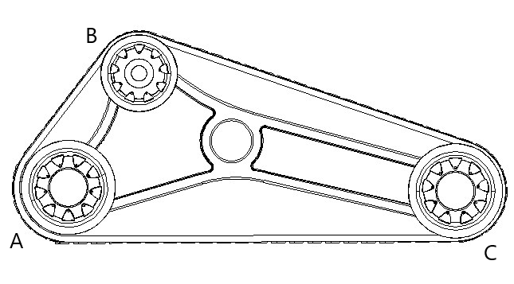

Figure 1: Side View

Case 1 – Angle less than 90°

For angle less than 90°, the length AC decreases. The lesser the distance between AC, lesser will be the climb height.

Case 2 - Angle more than 90°

For angle more than 90°, the stresses induced on the links AB, and BC will be more and therefore has a higher chance of failure. To counter the weight of the system, vertical reaction forces are induced by the wheels.

As the angle goes on increasing, the vertical forces by the wheels decreases and hence the links have to bear more stress and might fail easily.

The motor shaft is connected to the wheel through the coupling. A bearing housing is used to bear the radial load on the shaft. Two radial ball bearings have been placed in the groove provided inside the bearing housing.

The calculations for the motor torque are as follows (for a single motor):

The motor torque has to overcome three resistive forces

1. Rolling resistance force,

2. Acceleration force, and

3. Gradient Force.

Total mass = 11200g

Number of tires = 4

Mass on each tire = 11200/4 = 2800 g

1. Rolling resistance force

μr = Coefficient of rolling friction = 0.015

N = Weight acting on single tire = 2.8*9.8 N

rolling resistance = μr * N = 0.4116 N2

2. Acceleration force

The average acceleration value for army tanks was found out to be 1 m/s2 = a

M = mass of each tire = 0.1kg

Acceleration force = m*a= 0.1N

3. Gradient force

Maximum angle of climb = 30° (θ)

Gradient force = mgsinθ = 54.88N

Total resistive force (TRF) = 55.39 N

Motor torque = TRF * Wheel radius = 55.39 x 0.052 Nm = 3.36 Nm

This is the minimum torque required by a motor to drive a wheel.

This is the rotating base assembly, which is used to rotate the gun in all directions. The rotating base attached with the caster wheels is placed on the fixed base. The rotating base assembly is connected to the bevel gear assembly through a coupling.

The torque required for the motor can be calculated by:

τ=Iα

Where τ= Torque required to rotate the base

I=Combined moment of inertia of the base and the gun.

α= Desired angular acceleration.

## **Design**

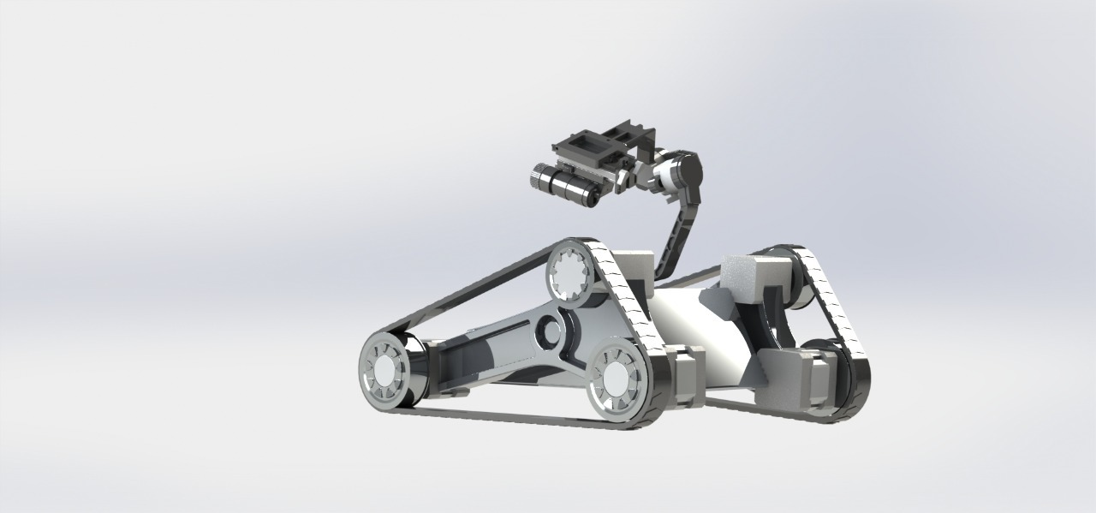

Figure 2: Final Rendering

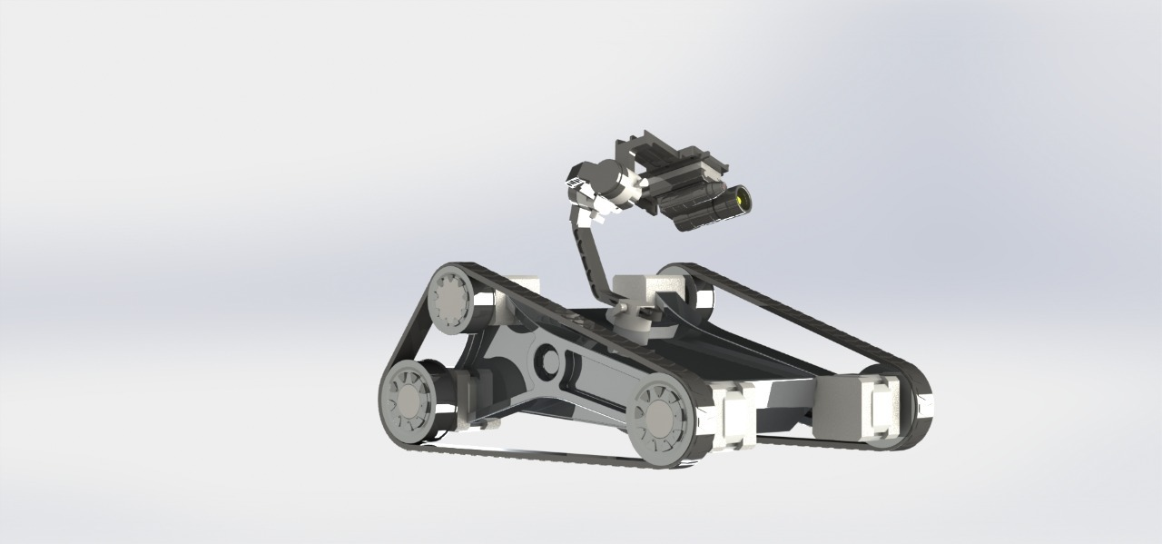

Figure 3: Final Rendering

We were unable to do a thorough static and dynamic analysis due to processing resource constraints. As a result, we conducted a structural analysis of the component that carries the majority of the assembly's weight. A downward force of 70N (approximating the total weight of the assembly to be 14kg and a 50-50 weight distribution) was applied.

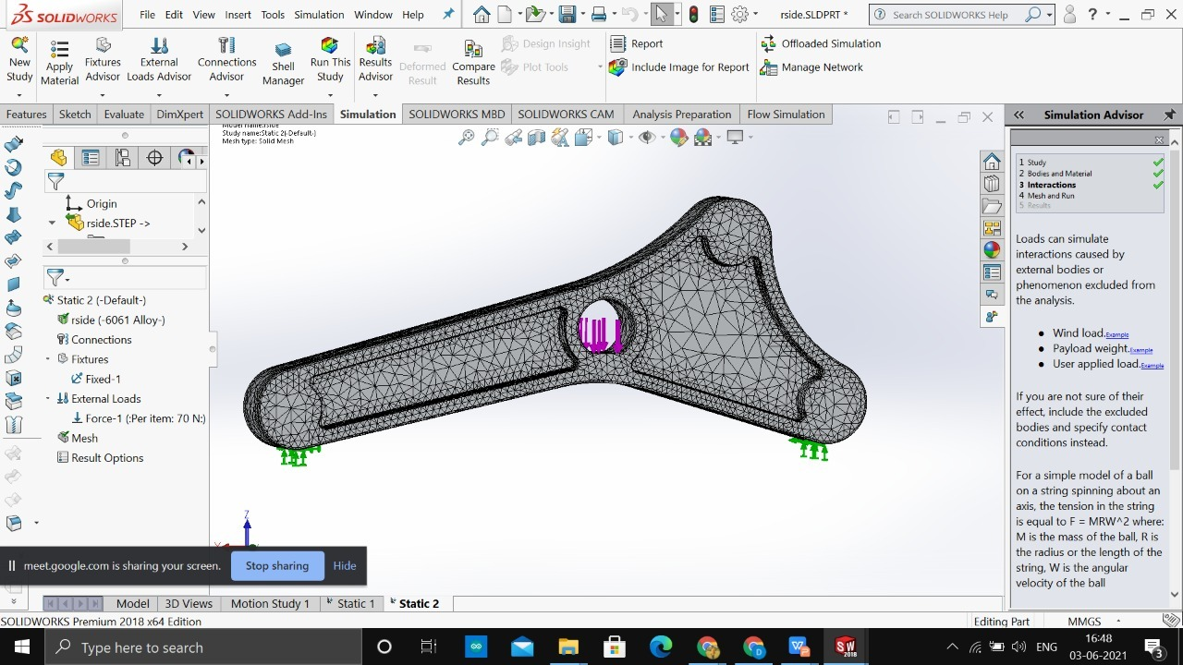

Figure 4: Mesh

The following results were obtained:

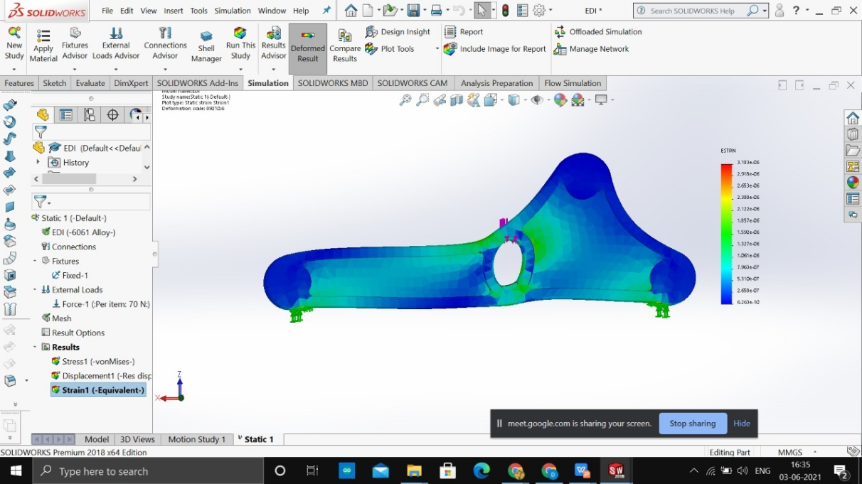

Figure 5: Maximum Strain

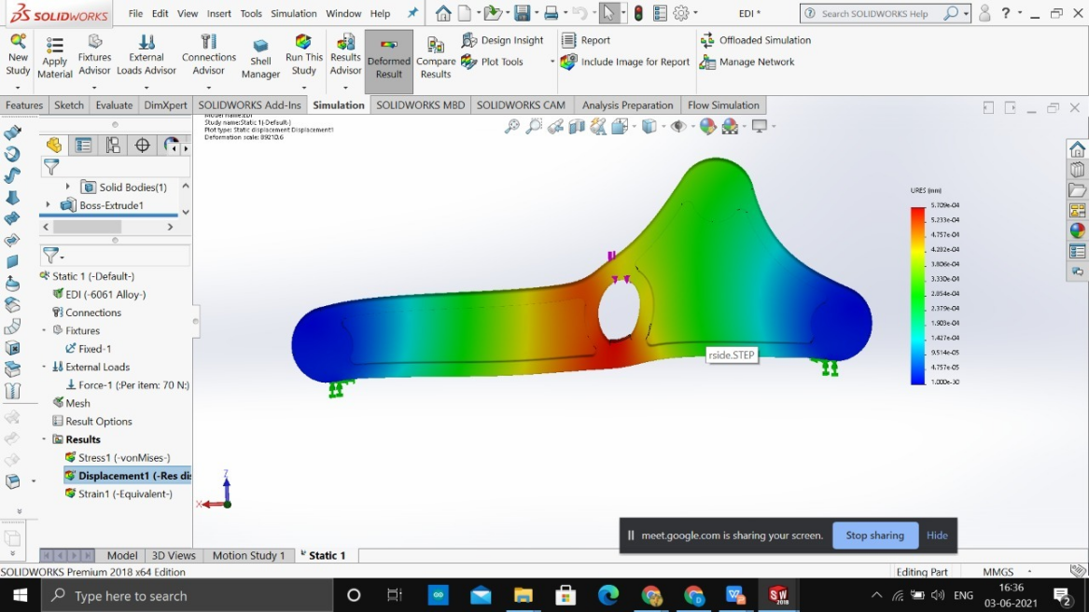

Figure 6: Maximum Deformation

The output had a maximum deformation of 5.7e-04mm, which is regarded safe and acceptable.

## **Material selection**

|  |  |  |  |  |
| --- | --- | --- | --- | --- |
| **Component** | **Material** | **Tensile Strength** | **Elongation** | **Density** |
| Chassis | Aluminium 6061 | 124–290 MPa | 12–25% | 2.70 g/cm3 |
| Wheels | PVC Rigid | 6.9 - 25 MPa | 25 - 58% | 1.3-1.7g/cm3 |
| Rubber Track | Rubber | 10-25 MPa | 650% | 1.2 kg/m³ |
| Crane Arms | PVC Rigid | 6.9 - 25 MPa | 25 - 58% | 1.3-1.7g/cm3 |

## **Electrical Components**

The electrical Components include the raspberry pi, raspi cam, Arduino board, L289n Motor driver, motors cooling fan, 12v Battery, servo motors, jumper wires, etc.

Raspberry pi is used as the master device in the bot also the processing power of raspberry pi is also good. Raspberry pi comes with an ubantu operating system. Other development boards such as Nvidia jetson or jetson nano can be used for the higher accuracy but it will increase the cost. The Arduino development board is used as the slave device which is used for controlling the motors and the servos. The raspi cam is used to detect the frames of the particular location where the bot is located. Thus, the further processing on the frames is done by the algorithm designed.

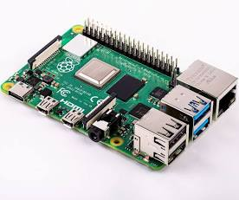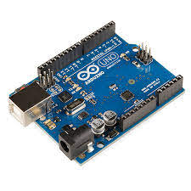

Raspberry pi Arduino

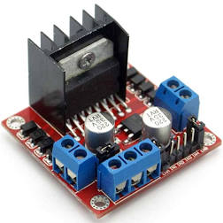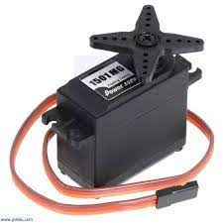

L289n Servo Motors

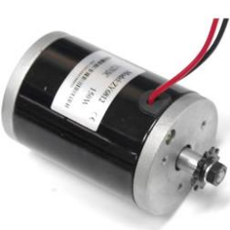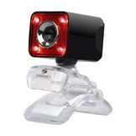

Dc motors Camera

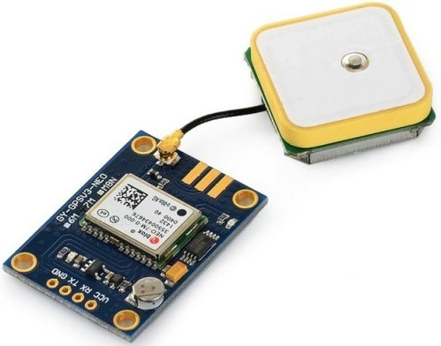

G.P.S. Module

## **Programming**



The code begins with importing the libraries required such as cv2, NumPy, TensorFlow, keras,

Os, argparse, sys, importlib.util, etc. Then the trained neural network model is imported using the TensorFlow and keras. Thereafter the images i.e. the frames are captured through the camera using the cv2 coding. The center of the frame are stored in the variables initially. Then the image processing is done on the image to make the image clear. Thereafter, the deeplearning model is used, which detects the Human presence in the image. Then the bounding rectangle is created and the centroid is calculated. Then by taking the error between the center of the frame and the centroid pid tuning is done and thus the required angle is sent to the Arduino via fourbit number transferring. Further the Arduino code runs. Then the servos move accordingly until the error nearly becomes zero. Thus, the gun aims at the human and then seeks the permission whether to shoot or not. Hence the final controlling i.e., the decision whether to kill the person or not is not in control of the bot but lies in the hands of the control room. Hence as compared to the other autonomous bot, our bot is quite safe and can be used practically.

The current deep learning model that is used in the bot is S.S.D. i.e., Single Shot Detector. Faster RCNN model can be used which will increase the accuracy. The remote API connection is made to the bot using the VNC server connection. Also, the bot can be operated manually as well as autonomously.

***E. Software information***

***RaspberrPiOS:*** Raspberry PiOS (formerly Raspbian) is a [Debian](https://en.wikipedia.org/wiki/Debian)-based [operating system](https://en.wikipedia.org/wiki/Operating_system) for [Raspberry Pi](https://en.wikipedia.org/wiki/Raspberry_Pi). Since 2015, it has been officially provided by the [RaspberryPi Foundation](https://en.wikipedia.org/wiki/Raspberry_Pi_Foundation) as the primary operating system for the Raspberry Pi family of compact [single-board computers](https://en.wikipedia.org/wiki/Single-board_computers).As our project is based on Object detection and soldier detection, we used raspberry pi OS for running CNN model and Haar Cascade classifier.

***Arduino IDE***: Arduino IDE is an open-source Arduino Software (IDE) makes it easy to write code and upload it to the board. In our project we used for controlling DC motors, Servo motors and also for getting binary code from RPi.

***Microsoft Visual Studio***: Microsoft Visual Studio is an integrated development environment from Microsoft. It is used to develop computer programs, as well as websites, web apps, web services and mobile apps.In our case, we used it for creating GUI

and also, for testing code related to OpenCV.

***Solidworks: SolidWorks*** is a solid modeling computer-aided design and computer-aided engineering computer program published by Dassault Systems. We did CAD modelling of our model using solidworks.

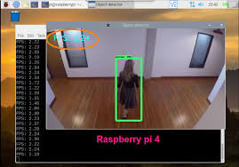

Figure 7: Human Detection

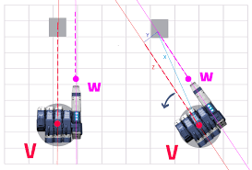

Figure 8: Autonomous Aiming

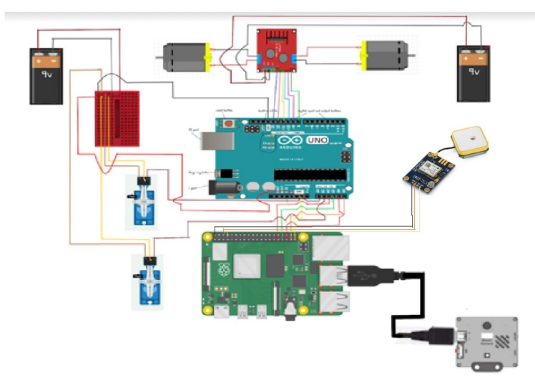

Figure 10: Circuit Diagram

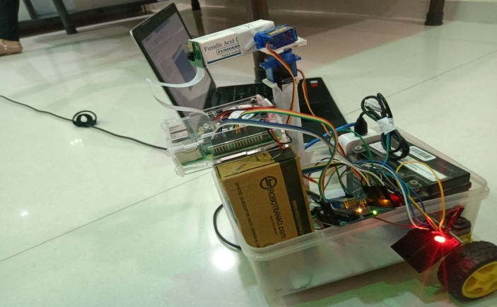

Figure 11: Electric model

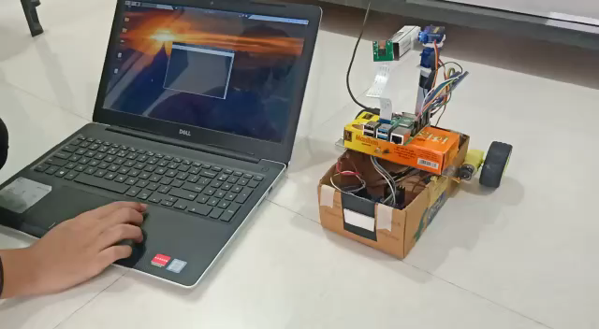

Figure 12: Manual movement

# **F. User Interface**

A User interface is also created for the easy view of the total system. In the UI we can see the live stream of the camera and also detection of the various objects are also shown. Also, in the side box, the detected object names are shown. The bot state is also shown i.e. the movement of the bot and the camera. The GPS coordinates are also shown in the GUI.

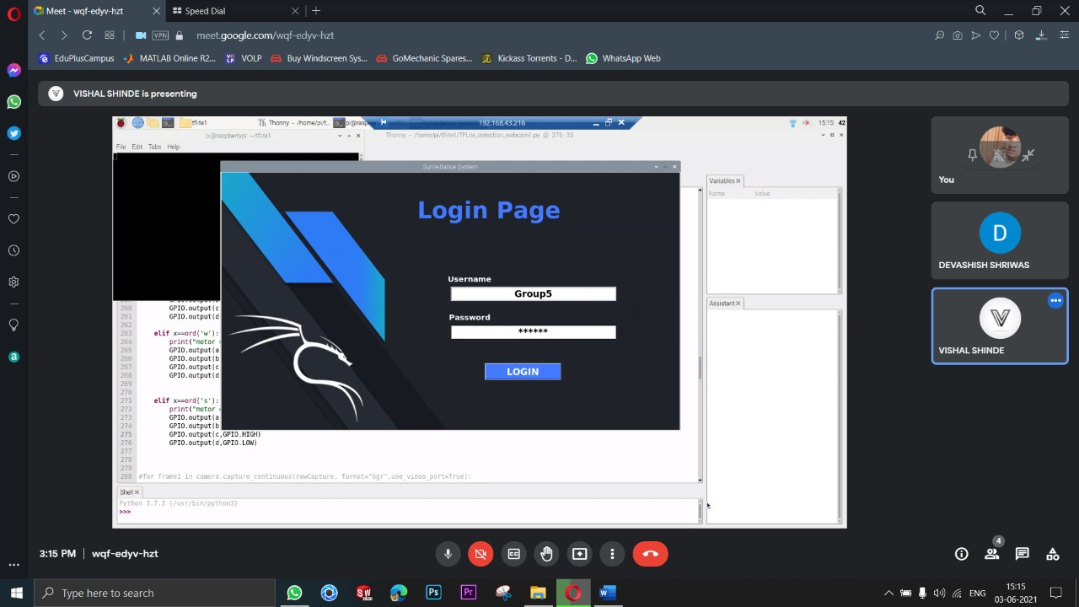

Figure 13: Login Page



Figure 14: Login Page

**G. CNN for Soldier Detection**

The SSD model is capable of detecting number of objects but it can’t detect whether the person is a soldier or not. So, for this purpose we created our own CNN which can detect whether the person is a Indian Soldier or not.

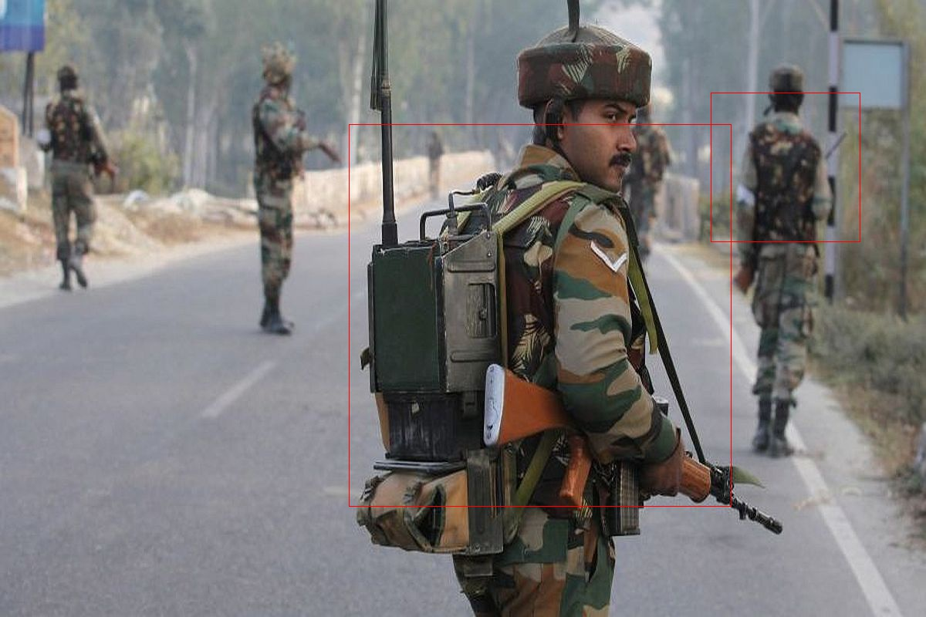

Figure 15: Soldier Detection

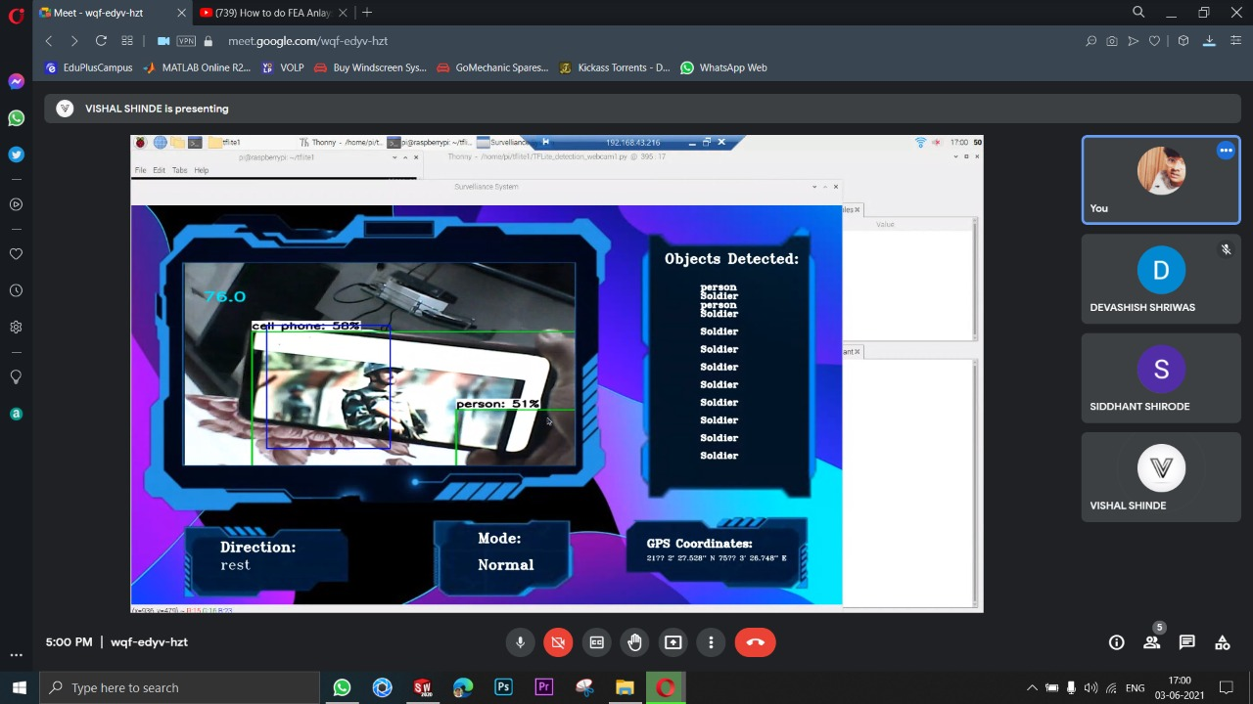

Figure 16: Soldier detection on UI

# **Results and Discussions**

The project is completed under the guidance prof Ganesh Dongre. The accuracy of the deep learning model is good but can be increased by using a faster RCNN model or greater accuracy microcontroller such as jetson or jetson nano but this leads to increase in cost. The servos work very accurately and aims the human accurately.

# **Conclusion**

Automation has been a boon to all segments of society. It has not only made lives easier, but also paved the way for technological revolutions in both the public and private sectors. Benefits in progress related to automation are numerous. Automation provides an immediate force-multiplier effect because of the machine’s ability to conduct basic tasks such as product assembly, material handling, and palletization, thereby removing the need to hire and train personnel for those duties (Lucas, 2016). But the potential benefits of lethal automation are even greater. During instances of armed conflict, complex technologies that employ intricate tools and algorithms allow for the mechanization of more numerous and difficult tasks. Using a maximally autonomous weapon in combat may also be advantageous in environments with poor or broken-down communication links, since they have the capacity to continue operating on their own.

# **Limitations**

Poor recoil management

Currently we do not have recoil system which could seamlessly transfer all the recoil energy out of the vehicle. The extrusions currently being used in guns are very effective when it comes to planar ground surface. But our vehicle is well suited for the “off-road” kind of surfaces in which the topography is unpredictable. We can accommodate the weight of these extrusions in our vehicle but its ability to execute does not suit our utility.

**Acknowledgment**

The objective of this project is to provide clear and thorough presentation of theory and practical knowledge of All Terrain “Surveillance and Intrusion Detection System”. To achieve this objective, the group members by no means have worked alone as these ideas have been shaped by comments, suggestions and acceptance given by Prof. Ganesh Dongre. We express our sincere thanks to the management of Vishwakarma Institute of Technology, Pune for allowing us to carry out such educational projects. We express our feelings and respect towards our parents, without their blessings, help and motivation this project could not have been completed and would have been just a dream for us. We are thankful to all those whom we might have inadvertently failed to mention here but have a positive contribution in successful completion of this project.

**References**

1. R. Fierro, F. Lewis, and A. Lowe, “Hybrid control for a class of underactuated mechanical systems,” IEEE Transactions on Systems, Man and Cybernetics, Part A: Systems and Humans, vol. 29, no. 6, pp. 649–4
2. Lawton, D. B. (2003). The influence of additives on the temperature, heat transfer, wear, fatigue life, and self-ignition characteristics of a 155 mm gun. J. Pressure Vessel Technol., 125(3), 315-320.
3. Yang, H. A., Rojas, L. C. V., Xia, C., & Guo, Q. (2014). Dynamic rocker-bogie: a stability enhancement for highspeed traversal. IAES International Journal of Robotics and Automation, 3(3), 212.
4. https://digitalcommons.calpoly.edu/cgi/viewcontent.cgi?article=1243&context=eesp
5. https://www.researchgate.net/publication/233237360_A_Track-Wheel-Terrain_Interaction_Model_for_Dynamic_Simulation_of_Tracked_Vehicles
6. Wong, J.Y., Garber, M., and Preston-Thomas, J.: Theoretical prediction and experimental substantiation of the ground pressure distribution and tractive performance of tracked vehicles. Proc. Instn Mech. Engrs, 1984, 198 (D15), pp.265-285.
7. https://www.researchgate.net/publication/315917643_Gun_turret_automatic_weapon_control_system_design_and_realization

1.